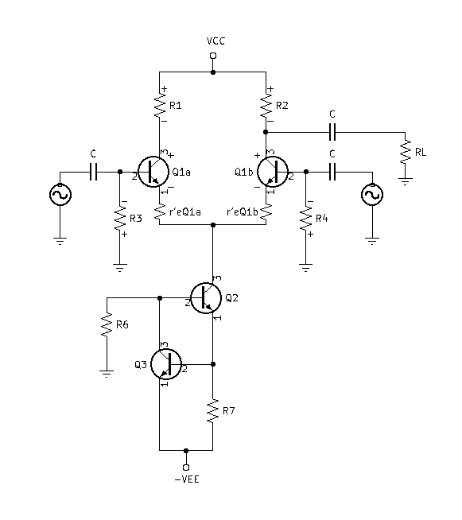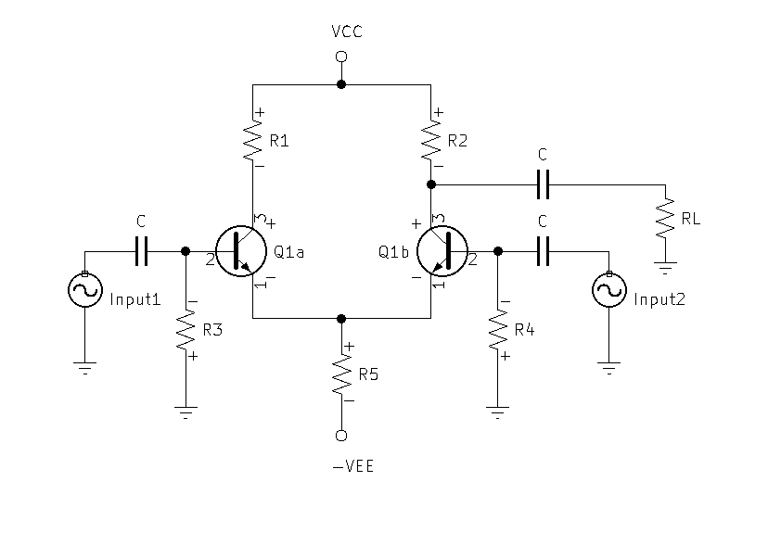**Replace R5 with a Constant Current Source**:

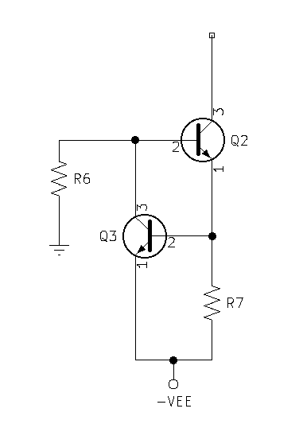**Calculate R7 & R6:**

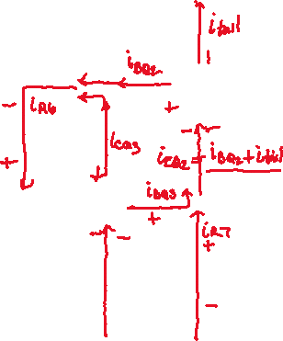

* :
  + - * If the betas are equal and the base currents are equal, then ${IC}_{Q3}={IC}_{Q2}=I_{tail}$
 $IR6=I_{tail}+{IB}_{Q2}$     * Now put ${IB}_{Q2}$ in terms of $I_{tail}$
 ${IB}_{Q2}=\frac{I_{tail}}{Beta}$ $IR6=I_{tail}+\frac{I_{tail}}{Beta}$    * Factor out $I_{tail}$

$IR6=I_{tail}(1+\frac{1}{Beta})$

$VR6=VEE-{VBE}_{Q2}-{VBE}_{Q3}$

$VR6=VEE-1.4v$

$R6=\frac{VEE-1.4v}{I_{tail}(1+\frac{1}{Beta})}$